Human Biology ATAR – Task 5: Test
Digestive, Excretory and Musculoskeletal Systems (6%)
Name:
Time allowed: 55 Minutes + 5 minutes reading time
Section | Your Mark | Marks available | Percentage of Test
Multiple Choice (A) |  | 15 | 25%
Short Answer (B) |  | 35 | 58%
Extended Response (C) |  | 10 | 17%
 |  | 60 | 100%

Declaration of Authenticity
I (Student Name) _____________________ declare that this work is my own and I have not plagiarised from any source.

Signature:
Date:

Section A – Multiple Choice (15 marks)
Answer all questions by clearly circling the letter ONLY. Use only a BLUE or BLACK pen. If you make a mistake, place a CROSS through the letter; do not erase or use correction fluid, and circle your new answer. Marks will not be deducted for incorrect answers. No marks will be given if more than one answer is completed for any question
- The series of muscular contractions that moves food along the digestive tract is called:

  - Periosteum
  - Peristalsis
  - Pericardium
  - Perimysium

- Urine is stored in the:

  - Kidney
  - Bladder
  - Urethra
  - Ureter

- The flap of tissue that covers the trachea during swallowing is called the:

  - Glottis
  - Epiglottis
  - Peristalsis
  - Larynx

- The process of deamination occurs in the:

- Kidney
- Pancreas
- Stomach
- Liver

- The projections found along the walls of the small intestine are called:

- Mucosa
- Villi
- Rennin
- Ileum

- Which of the following reactions is catalyzed by lipase?

  - Starch to maltose
  - Fats to fatty acids
  - Polypeptides to amino acids
  - Fatty acids to micelles

- Absorption of digested food occurs largely in the:
- Small intestine
- Pancreas
- Stomach
- Large intestine

- Bile is involved in the breakdown of fats. It is:

- Produced in the gall bladder and stored in the liver
- Produced in the liver and stored in the gall bladder
- Produced in the pancreas and stored in the liver
- Produced and stored in the liver

- In the sliding filament theory of muscle contraction which of the following occurs:

  - The I bands lengthen
  - The actin filaments slide past the myosin filaments
  - The Z lines move further apart
  - The A band shortens

- The vertebral column, rib cage and skull form the:

  - Axial skeleton
  - Appendicular skeleton
  - Pectoral girdle
  - Pelvic girdle

- The shaft of a long bone is called the:

  - Periosteum
  - Trabuculae
  - Diaphysis
  - Epiphysis

- Blood in the glomerulus is under high pressure due to

- The pressure applied by the renal artery and the small diameter of the efferent arteriole
- the pressure applied by the renal artery and the small diameter of the afferent arteriole
- The pressure applied by the renal vein and the small diameter of the efferent arteriole
- The pressure applied by the renal vein and the small diameter of the afferent arteriole

13. Where would you not expect mechanical digestion to take place?

  - Stomach
  - Mouth
  - Small intestine
  - Large intestine

  - In order to bend the arm at the elbow the biceps muscle must contract. At the same time the triceps muscle must?

- Relax
- Shorten
- Push on the ulna
- Pull on the radius

  - Which line represents the process of deamination?

    - Amino acid + carbohydrate ammonia + oxygen
    - Ammonia + carbohydrate amino acid + oxygen
    - Amino acid + oxygen carbohydrate + ammonia
    - Ammonia + oxygen amino acid + carbohydrate

END OF MULTIPLE CHOICE
Section B – Short Answer
Answer all questions in the spaces provided. Use only BLUE or BLACK pen.

      - Name a part of the alimentary canal that is involved in (4 marks)

  - Secretion of enzymes: _________________________________
  - Absorption of nutrients: ________________________________
  - Peristalsis: _________________________________
  - Defecation: _________________________________

      - The diagram below shows a single villus

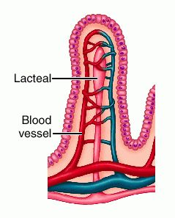
(iii)

(i)

(ii)

        - Label the following structures ` (3 marks)

          - ___________________________________
          - ___________________________________
          - ___________________________________

        - Identify the organ in which the pictured structure is located (1 mark)

____________________________________________________________

        - Describe why the villi are so small and numerous (1 mark)

____________________________________________________________________________________________________________________________________________________________________________________________________________________________________________________________________________

      - Use the diagram of a kidney to fill in the missing labels (5 marks)
(Note: Arrows show direction of blood flow)
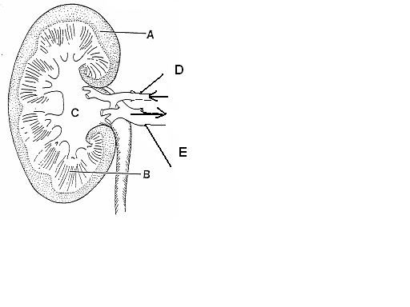

A _____________________________________________
B _____________________________________________
C _____________________________________________
D _____________________________________________
E _____________________________________________

  - Name of the structure that INITIALLY filters the blood in the kidney (1 mark)

_______________________________________________________________

  - Name the tube leading from the bladder to outside of the body (1 mark)

______________________________________________________________

        - Describe what happens to the urine output if the body fluids contain less water? (1 mark)

_______________________________________________________________

- Question 4 relates to the diagram below:

a. Label the attachments marked A to F (6 marks)

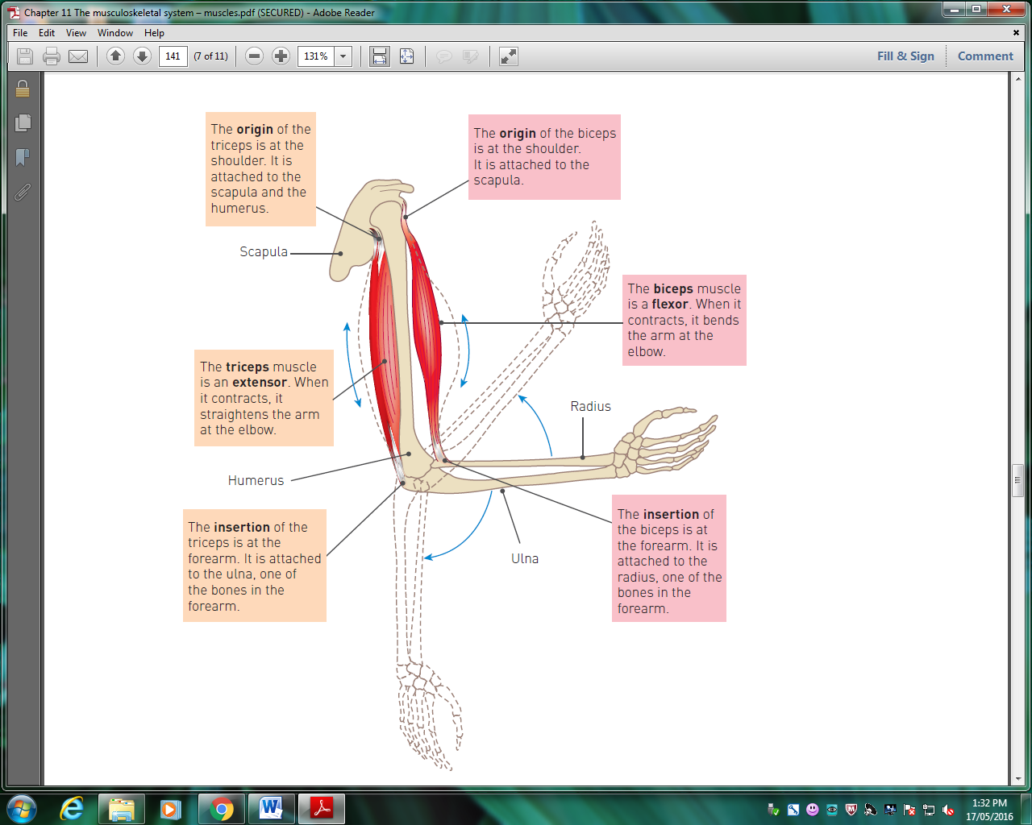
A
C
E
B
F
D

        - B and E are antagonistic muscles. Describe how these two muscles work together to cause:
(4 marks)
          - Flexion
__________________________________________________________________________________________________________________________________________________________________________________________
    - Extension
__________________________________________________________________________________________________________________________________________________________________________________________
- The Digestive System extracts nutrients from the food we eat and absorbs them into the body for use by cells.

              - Complete the below table by identifying the simpler units that these nutrients are broken down into during digestion. (3 marks)

Large, complex molecule | Small, simple molecule
Proteins
Carbohydrates
Fats

              - A Cholecystectomy is a surgical procedure where the gallbladder is removed, most often used to treat painful gallstones. People who have had their gallbladder removed are unable to control the release of bile into the small intestine. Predict a possible consequence of this. (1 mark)

___________________________________________________________________
___________________________________________________________________

              - Complete the table to compare and contrast mechanical digestion with Chemical Digestion. (4 marks)

Similarities
Differences
Mechanical digestion | Chemical digestion

END OF SECTION B

Section C – Extended Response
Write your answer on the lined pages provided. Answers should be in BLUE or BLACK pen

- The formation of urine by the nephron of the kidneys involves three major processes; filtration, reabsorption and secretion in the tubules. Explain each of these processes in detail (10 marks)

__________________________________________________________________________________________________________________________________________________________________________________________________________________________________________________________________________________________________________________________________________________________________________________________________________________________________________________________________________________________________________________________________________________________________________________________________________________________________________________________________________________________________________________________________________________________________________________________________________________________________________________________________________________________________________________________________________________________________________________________________________________________________________________________________________________________________________________________________________________________________________________________________________________________________________________________________________________________________________________________________________________________________________________________________________________________________________________________________________________________________________________________________________________________________________________________________________________________________________________________________________________________________________________________________________________________________________________________________________________________________________________________________________________________________________________________________________________________________________________________________________________________________________________________________________________________________________________________________________________________________________________________________________________________________________________________________________________________________________________________________________________________________________________________________________________________________________________________________________________________________________________________________________________________________________________________________________________________________________________________________________________________________________________________________________________________________________________________________________________________________________________________________________________________________________________________________________________________________________________________________________________________________________________________________________________________________________________________________________________________________________________________________________
______________________________________________________________________________________________________________________________________________________________________________________________________________________________________________________________________________________________________________________________________________________________________________________________________________________________________________________________________________________________________________________________________________________________________________________________________________________________________________________________________________________________

END OF TEST

